<https://www.youtube.com/watch?v=KIOeZ5cFZ50>

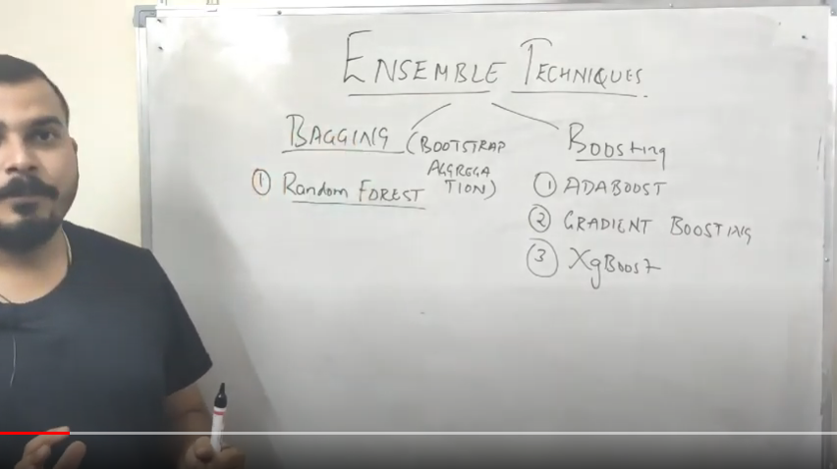

Ensemble – Combining multiple models

Bootstrap – Let’s say our data set has 1000 records, Process of creating multiple small-small data sets for multiple decision tress using technique, sampling with replacement, is called Bootstrap (Decision Trees –are called **Base Learners**)

Aggregation – Combining prediction of all decision trees and to reach conclusion using majority of votes (voting classifier) is called Aggregation

